**LAB ASSESSMENT**

1.Aiphabetic Order of ArrayList in Collections

**package** com;

**import** java.util.ArrayList;

**import** java.util.Collection;

**import** java.util.Collections;

**import** java.util.Comparator;

**import** java.util.List;

**public** **class** Library {

**int** book_id;

String book_name;

**int** book_price;

**public** **int** getBook_id() {

**return** book_id;

}

**public** **void** setBook_id(**int** book_id) {

**this**.book_id = book_id;

}

**public** String getBook_name() {

**return** book_name;

}

**public** **void** setBook_name(String book_name) {

**this**.book_name = book_name;

}

**public** **int** getBook_price() {

**return** book_price;

}

**public** **void** setBook_price(**int** book_price) {

**this**.book_price = book_price;

}

**public** Library(**int** book_id, String book_name, **int** book_price) {

**super**();

**this**.book_id = book_id;

**this**.book_name = book_name;

**this**.book_price = book_price;

}

**public** **static** Comparator<Library> *BookNameComparator* = **new** Comparator<Library>() {

**public** **int** compare(Library s1, Library s2) {

String BookName1 = s1.getBook_name().toUpperCase();

String BookName2 = s2.getBook_name().toUpperCase();

//ascending order

**return** BookName1.compareTo(BookName2);

//descending order

//return StudentName2.compareTo(StudentName1);

}};

@Override

**public** String toString() {

**return** "Library [book_id=" + book_id + ", book_name=" + book_name + ", book_price=" + book_price + "]";

}

**public** **static** **void** main(String[] args)

{

// Create a list of strings

ArrayList<Library> a = **new** ArrayList<Library>();

a.add(**new** Library(1,"Zoo",800));

a.add(**new** Library(2,"Aoo",800));

Collections.*sort*(a, Library.*BookNameComparator*);

**for**(Library ae: a){

System.***out***.println(ae);

}

}

}

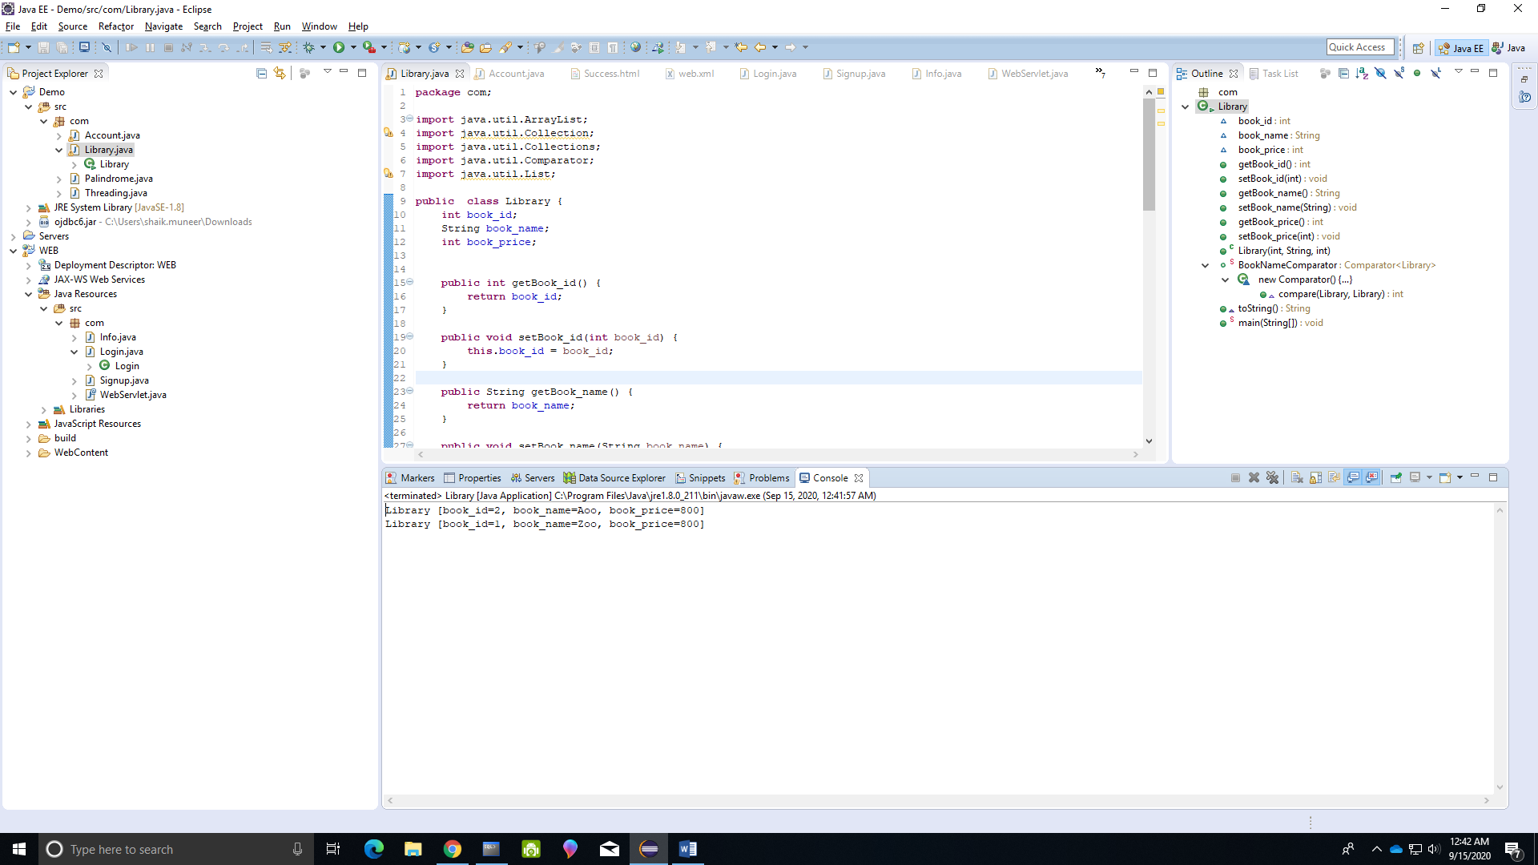

2.Creating Threads to print A to Z and 1 to 30

**package** com;

**class** Character **extends** Thread{

**public** **void** run(){

**for** (**int** i = 65;i<91;i++){

**char** c = (**char**)i;

System.***out***.println(c);

}

}

}

**class** Number **extends** Thread{

**public** **void** run(){

**for** (**int** i = 1;i<31;i++){

System.***out***.println(i);

}

}

}

**public** **class** Threading {

**public** **static** **void** main(String[] args) {

Character c = **new** Character();

Number n = **new** Number();

c.start();

n.start();

}

}

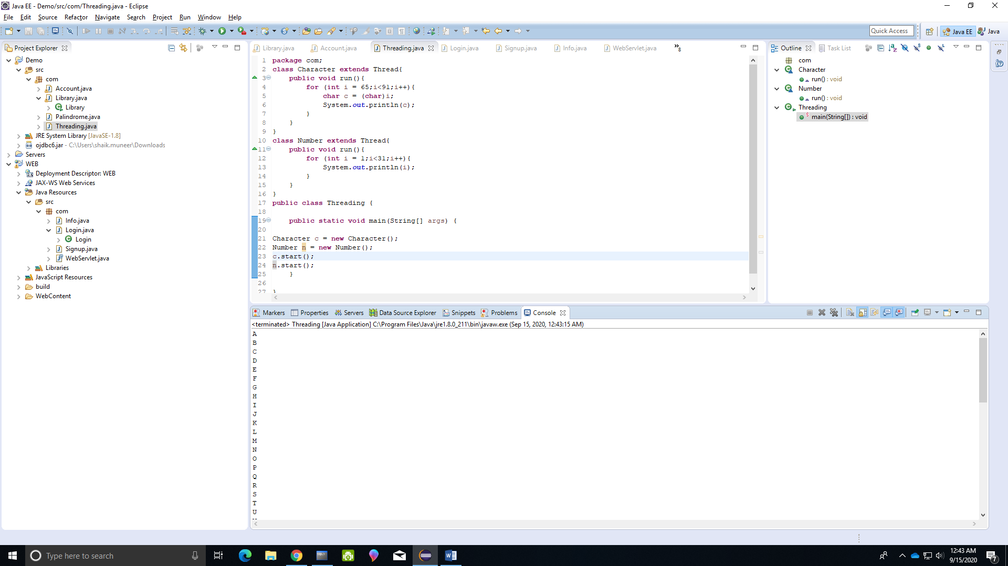

3. Palindrome Between two numbers

**package** com;

**public** **class** Palindrome

{

**public** **static** **int** Pal(**int** n)

{

**int** rev = 0;

**for** (**int** i = n; i > 0; i /= 10)

rev = rev * 10 + i % 10;

**return**(n == rev) ? 1 : 0;

}

**public** **static** **void** Pal(**int** min, **int** max)

{

**for** (**int** i = min; i <= max; i++){

**if** (*Pal*(i)==1)

System.***out***.print(i + " "); }

**int** count = 0;

**for** (**int** i = min; i <= max; i++) {

String s = i+"";

StringBuffer sb = **new** StringBuffer(s);

**if**(s.equals(sb.reverse().toString())){

count++;

}

}

System.***out***.println("\nno of palindromes"+count);

}

**public** **static** **void** main(String args[])

{

*Pal*(200, 500);

}

}

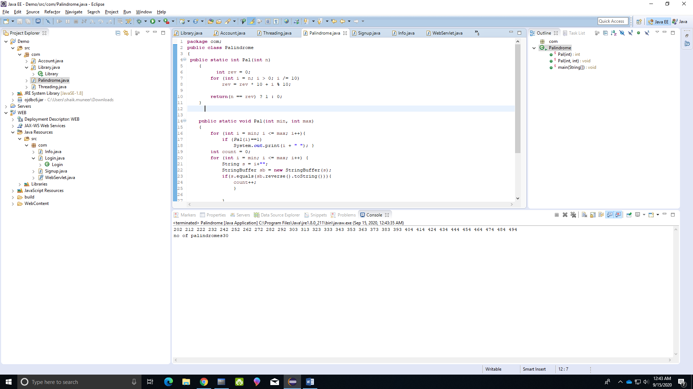

4. Insert delete update using jdbc

package com;

import java.sql.Connection;

import java.sql.DriverManager;

import java.sql.PreparedStatement;

import java.util.Scanner;

class Details{

int oldaccno;

int accno;

String name;

int balance;

public int getAccno() {

return accno;

}

public void setAccno(int accno) {

this.accno = accno;

}

public String getName() {

return name;

}

public void setName(String name) {

this.name = name;

}

public int getBalance() {

return balance;

}

public void setBalance(int balance) {

this.balance = balance;

}

public int getOldaccno() {

return oldaccno;

}

public void setOldaccno(int oldaccno) {

this.oldaccno = oldaccno;

}

@Override

public String toString() {

return "Details [accno=" + accno + ", name=" + name + ", balance=" + balance + "]";

}

}

public class Account {

public static void main(String[] args){

try{

Scanner sc = new Scanner(System.in);

System.out.println("Select one option\n1.INSERT\n2.UPDATE\n3.DELETE");

System.out.println("Enter your Option:");

int o = Integer.parseInt(sc.nextLine());

switch(o){

case 1:

System.out.println("Enter ACCID");

int id = Integer.parseInt(sc.nextLine());

System.out.println("Enter Balance");

int bal = Integer.parseInt(sc.nextLine()); ;

System.out.println("Enter Name");

String name = sc.nextLine();

Details d = new Details();

d.setAccno(id);

d.setName(name);

d.setBalance(bal);

Class.forName("oracle.jdbc.driver.OracleDriver");

System.out.println("Driver loaded successfully..");

Connection con=DriverManager.getConnection("jdbc:oracle:thin:@localhost:1521/xe","system" ,"system");

System.out.println("Connection established successfully...");

String sql = "insert into accountss values(?,?,?)";

PreparedStatement st = con.prepareStatement(sql);

st.setInt(1,d.getAccno());

st.setString(2,d.getName());

st.setInt(3,d.getBalance());

int rs = st.executeUpdate();

System.out.println(rs);

if(rs>0){

con.commit();

System.out.println("Inserted");

}

break;

case 2:

System.out.println("Enter old new ACCID");

int old = Integer.parseInt(sc.nextLine());

System.out.println("Enter new ACCID");

int i = Integer.parseInt(sc.nextLine());

System.out.println("Enter new Balance");

int ba = Integer.parseInt(sc.nextLine());

System.out.println("Enter Name");

String nam = sc.nextLine();

Details de = new Details();

de.setAccno(i);

de.setName(nam);

de.setBalance(ba);

de.setOldaccno(old);

String sq = "update accountss set accno=? ,name =?, balance=? where accno=?";

Connection conn=DriverManager.getConnection("jdbc:oracle:thin:@localhost:1521/xe","system" ,"system");

PreparedStatement sts = conn.prepareStatement(sq);

sts.setInt(1,de.getAccno());

System.out.println(de.getAccno());

sts.setString(2,de.getName());

System.out.println(de.getName());

sts.setInt(3,de.getBalance());

System.out.println(de.getBalance());

sts.setInt(4,de.getOldaccno());

System.out.println(de.getOldaccno());

int rsw = sts.executeUpdate();

System.out.println(rsw);

if(rsw>0){

conn.commit();

System.out.println("Updated");

}

break;

case 3:

System.out.println("Enter ACCId you want to delete");

int g = sc.nextInt();

Details des = new Details();

des.setAccno(g);

String s = "delete from accountss where accno=?";

Connection co=DriverManager.getConnection("jdbc:oracle:thin:@localhost:1521/xe","system" ,"system");

PreparedStatement sg = co.prepareStatement(s);

sg.setInt(1,des.getAccno());

System.out.println(des.getAccno());

int rswr = sg.executeUpdate();

System.out.println(rswr);

if(rswr>0){

co.commit();

System.out.println("deleted");

}

break;

}

}

catch(Exception e){

System.out.println(e);

}

}

}

Sql

create accountss(accno number primary key,name varchar(20) not null,balance number not null);

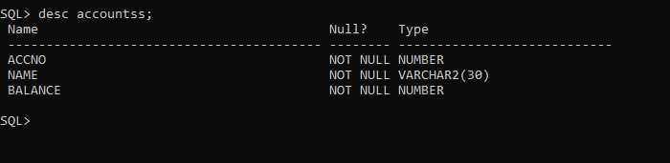

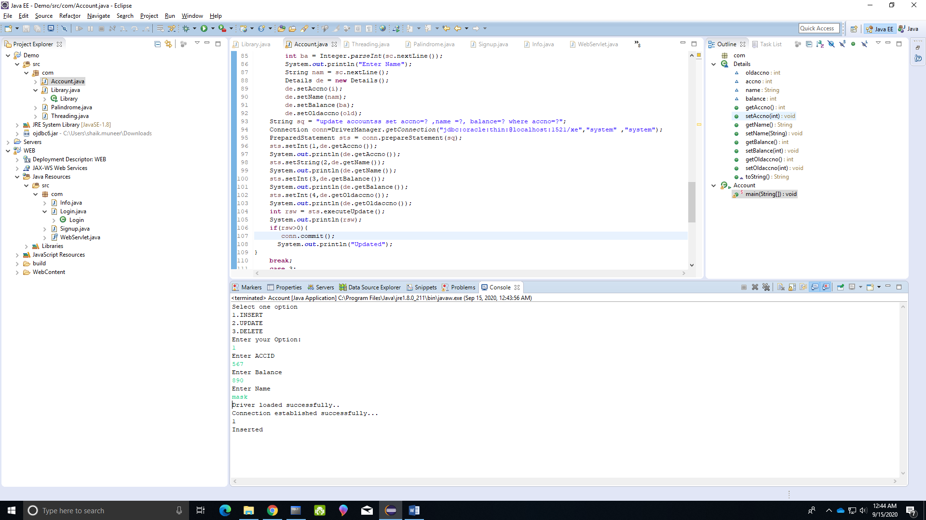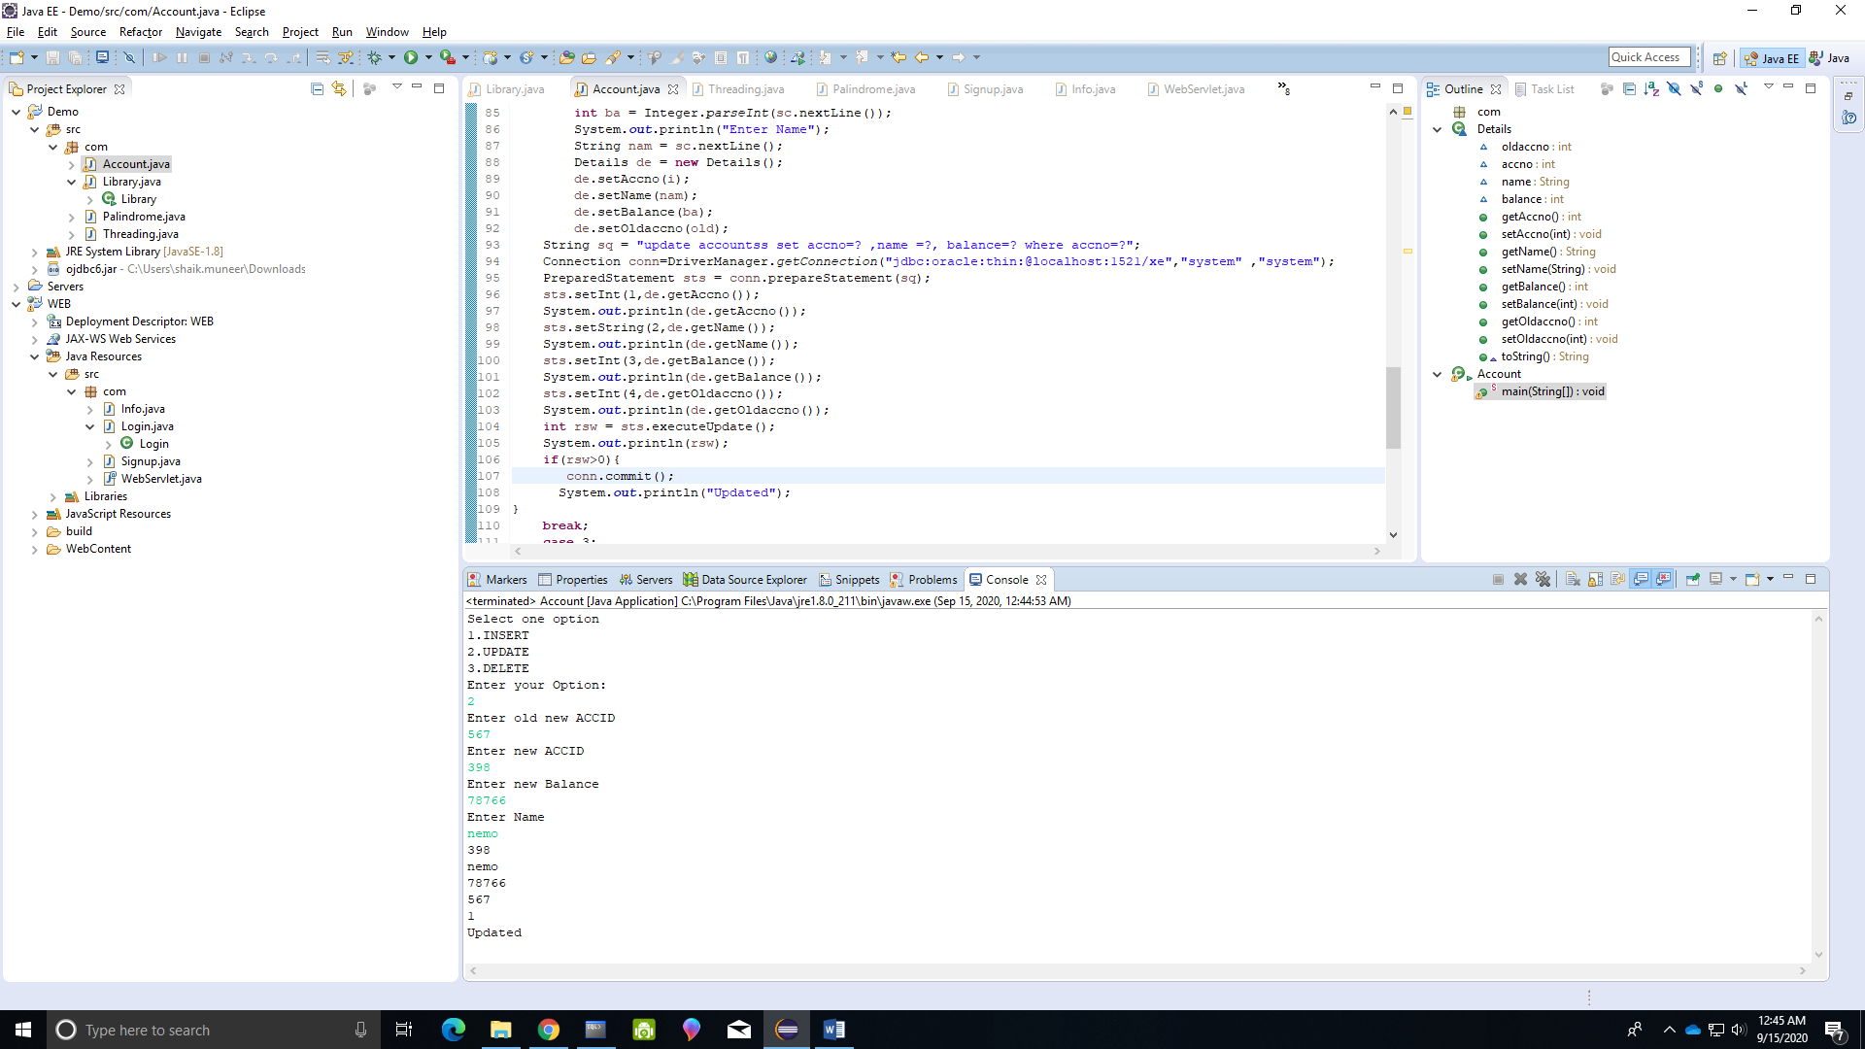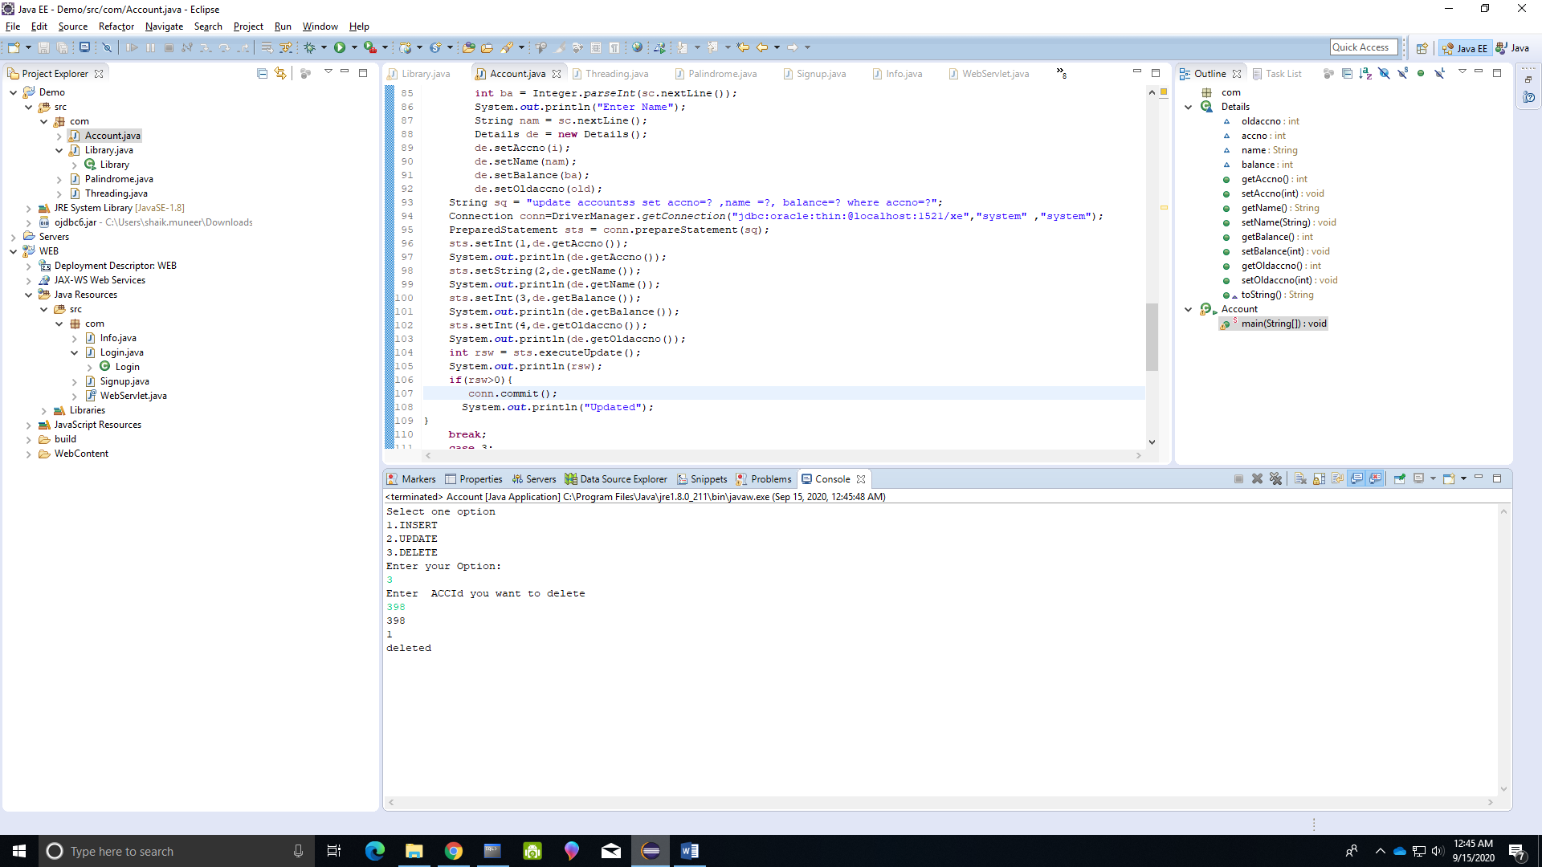

5.Creating login, Signup and HomePage

Home.html:

<!DOCTYPE html>

<html>

<head>

<meta charset=*"ISO-8859-1"*>

<title>Insert title here</title>

</head>

<body>

<a href=*'login.html'*>Login</a>

<a href=*'Signup.html'*>Signup</a>

</body>

</html>

Login.html:

<!DOCTYPE html>

<html>

<head>

<meta charset=*"ISO-8859-1"*>

<title>Insert title here</title>

</head>

<body>

<Form action=*"Login"*>

Email<input type=*"email"* name=*"email"*>

Password<input type=*"password"* name=*"password"*>

<button>LOGIN</button>

</Form>

</body>

</html>

Signup.html:

<!DOCTYPE html>

<html>

<head>

<meta charset=*"ISO-8859-1"*>

<title>Insert title here</title>

</head>

<body>

<Form action=*"Signup"*>

Username<input type=*"text"* name=*"username"*><br><br>

Email<input type=*"email"* name=*"email"*><br><br>

Password<input type=*"password"* name=*"password"*><br><br>

Gender<input type=*"text"* name=*"gender"*><br><br>

City<input type=*"text"* name=*"city"*><br><br>

MobileNo<input type=*"number"* name=*"mobileno"*><br><br>

<button>SIGNUP</button>

</Form>

</body>

</html>

Welcome.html:

<!DOCTYPE html>

<html>

<head>

<meta charset=*"ISO-8859-1"*>

<title>Insert title here</title>

</head>

<body>

Welcome!

</body>

</html>

Error.html:

<!DOCTYPE html>

<html>

<head>

<meta charset=*"ISO-8859-1"*>

<title>Insert title here</title>

</head>

<body>

INVALID EMAIL OR PASSWORD

</body>

</html>

Success.html

<!DOCTYPE html>

<html>

<head>

<meta charset=*"ISO-8859-1"*>

<title>Insert title here</title>

</head>

<body>

Account Created SuccessFully

<a href=*'login.html'*>Login</a>

</body>

</html>

Web.xml:

<?xml version=*"1.0"* encoding=*"UTF-8"*?>

<web-app xmlns:xsi=*"http://www.w3.org/2001/XMLSchema-instance"* xmlns=*"http://java.sun.com/xml/ns/javaee"* xsi:schemaLocation=*"http://java.sun.com/xml/ns/javaee http://java.sun.com/xml/ns/javaee/web-app_2_5.xsd"* id=*"WebApp_ID"* version=*"2.5"*>

<display-name>WEB</display-name>

<welcome-file-list>

<welcome-file>index.html</welcome-file>

<welcome-file>index.htm</welcome-file>

<welcome-file>index.jsp</welcome-file>

<welcome-file>default.html</welcome-file>

<welcome-file>default.htm</welcome-file>

<welcome-file>default.jsp</welcome-file>

</welcome-file-list>

<servlet>

<description></description>

<display-name>Signup</display-name>

<servlet-name>Signup</servlet-name>

<servlet-class>com.Signup</servlet-class>

</servlet>

<servlet-mapping>

<servlet-name>Signup</servlet-name>

<url-pattern>/Signup</url-pattern>

</servlet-mapping>

<servlet>

<description></description>

<display-name>Login</display-name>

<servlet-name>Login</servlet-name>

<servlet-class>com.Login</servlet-class>

</servlet>

<servlet-mapping>

<servlet-name>Login</servlet-name>

<url-pattern>/Login</url-pattern>

</servlet-mapping>

</web-app>

Login.java:

package com;

import java.io.IOException;

import java.sql.Connection;

import java.sql.DriverManager;

import java.sql.PreparedStatement;

import java.sql.ResultSet;

import javax.servlet.ServletException;

import javax.servlet.http.HttpServlet;

import javax.servlet.http.HttpServletRequest;

import javax.servlet.http.HttpServletResponse;

@WebServlet("/Login")

public class Login extends HttpServlet {

private static final long serialVersionUID = 1L;

protected void doGet(HttpServletRequest request, HttpServletResponse response) throws ServletException, IOException {

String email =request.getParameter("email");

String password = request.getParameter("password");

try{

Info d = new Info();

d.setEmail(email);

d.setPassword(password);

Class.forName("oracle.jdbc.driver.OracleDriver");

System.out.println("Driver loaded successfully..");

Connection con=DriverManager.getConnection("jdbc:oracle:thin:@localhost:1521/xe","system" ,"system");

System.out.println("Connection established successfully...");

String sql = "select * from signup where email=? and password=?";

PreparedStatement st = con.prepareStatement(sql);

st.setString(1, d.getEmail());

st.setString(2, d.getPassword());

ResultSet rs = st.executeQuery();

if(rs.next()){

System.out.println(rs.getString(1)+" "+rs.getString(2));

response.sendRedirect("Welcome.html");

}

else{

response.sendRedirect("Error.html");

}

}

catch(Exception e){

System.out.println(e);

}

}

}

Signup.java:

package com;

import java.io.IOException;

import java.sql.Connection;

import java.sql.DriverManager;

import java.sql.PreparedStatement;

import javax.servlet.ServletException;

import javax.servlet.http.HttpServlet;

import javax.servlet.http.HttpServletRequest;

import javax.servlet.http.HttpServletResponse;

class Details{

String username;

String email;

String password;

String gender;

String city;

int mobileno;

public String getUsername() {

return username;

}

public void setUsername(String username) {

this.username = username;

}

public String getEmail() {

return email;

}

public void setEmail(String email) {

this.email = email;

}

public String getPassword() {

return password;

}

public void setPassword(String password) {

this.password = password;

}

public String getGender() {

return gender;

}

public void setGender(String gender) {

this.gender = gender;

}

public String getCity() {

return city;

}

public void setCity(String city) {

this.city = city;

}

public int getMobileno() {

return mobileno;

}

public void setMobileno(int mobileno) {

this.mobileno = mobileno;

}

}

@WebServlet("/Signup")

public class Signup extends HttpServlet {

private static final long serialVersionUID = 1L;

protected void doGet(HttpServletRequest request, HttpServletResponse response) throws ServletException, IOException {

try{

String username = request.getParameter("username");

String email =request.getParameter("email");

String password = request.getParameter("password");

String gender = request.getParameter("password");

String city = request.getParameter("password");

int mobileno = Integer.parseInt(request.getParameter("mobileno"));

Details d = new Details();

d.setUsername(username);

d.setEmail(email);

d.setPassword(password);

d.setGender(gender);

d.setCity(city);

d.setMobileno(mobileno);

Class.forName("oracle.jdbc.driver.OracleDriver");

System.out.println("Driver loaded successfully..");

Connection con=DriverManager.getConnection("jdbc:oracle:thin:@localhost:1521/xe","system" ,"system");

System.out.println("Connection established successfully...");

String sql = "insert into signup values(?,?,?,?,?,?)";

PreparedStatement st = con.prepareStatement(sql);

st.setString(1,d.getUsername());

st.setString(2,d.getEmail());

st.setString(3,d.getPassword());

st.setString(4,d.getGender());

st.setString(5,d.getCity());

st.setInt(6,d.getMobileno());

int rs = st.executeUpdate();

System.out.println(rs);

if(rs>0){

con.commit();

System.out.println("Inserted");

response.sendRedirect("Success.html");

}

else{

response.sendRedirect("Signup.html");

}

}

catch(Exception e){

System.out.println(e);

}

}

}

Info.java:

**package** com;

**public** **class** Info {

**public** String getEmail() {

**return** email;

}

**public** **void** setEmail(String email) {

**this**.email = email;

}

**public** String getPassword() {

**return** password;

}

**public** **void** setPassword(String password) {

**this**.password = password;

}

String email;

String password;

}

Webservlet.java:

**package** com;

**public** **@interface** WebServlet {

String value();

}

Sql

SQL> create table signup(Username varchar(20) not null, email varchar(30) primary key, password varchar(30) not null,gender varchar(20) not null,city varchar(20) not null,mobileno number not null);

